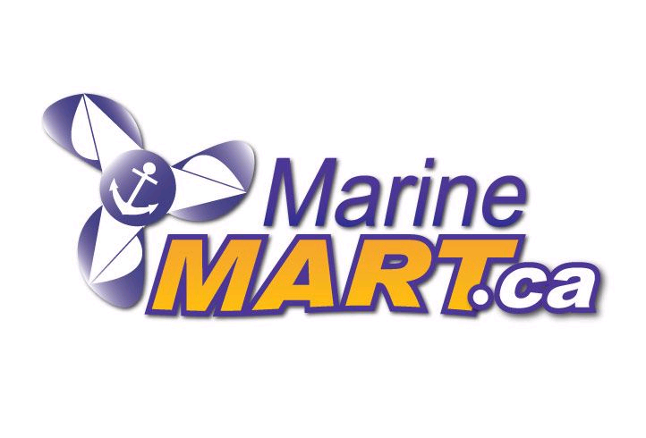

THE LARGEST MARINE & RV ACCESSORIES STORES IN ONTARIO

What is the Product Service Plan?

<conditions>
The Marine Mart Product Service Plan (MMSPL) is a value-added warranty service. We surpass most manufacturers' warranties by offering you additional benefits during the manufacturer's warranty and throughout your coverage period. By purchasing this Product Replacement Plan, you understand that this is a legal contract and you acknowledge that you have read and agreed to its terms. "Product Replacement Plan" and "Terms" refer to the "Plan". In this Plan, the words "us" and "our" (whether capitalized or not) refer to Marine Mart Inc. The words "you" and "your" (whether capitalized or not) refer to the purchaser of this Plan.

Product Eligibility: The Plan only covers products used primarily for personal or family purposes. This Plan covers Electronic products purchased from Marine Mart Inc.

Plan Duration: Coverage begins on the original purchase date of the product and ends 24 months after the date of the original invoice indicated on the original receipt, except as provided under "Coverage" and "Cancellation".

Manufacturer's Responsibility: This Plan complements and does not replace the manufacturer's warranty.
During the warranty period of the manufacturer and the duration of the Plan, the Plan provides certain additional benefits that are not covered by the manufacturer's warranty. If a covered product becomes defective during the warranty period of the manufacturer, the customer has the option
(A) obtain a replacement credit or
(B) to avail itself of the benefits under the manufacturer's warranty, while preserving the benefits under the Plan for a later date.

Coverage: This plan covers manufacturing and manpower defects occurring during normal use. The replacement under this Plan is a credit equivalent to the original purchase price including applicable taxes. This Plan covers power surges from the date of purchase of the product. When a replacement credit has been issued, the Plan will be deemed to have been complied with and will terminate on the date of issuance of the replacement credit.

Transferable: This Plan is transferable with the product. The Plan holder must have the original documents in hand to benefit from the replacement.

General Exclusions: This Plan DOES NOT cover:
1. replacement resulting from any cause other than normal use and operation of the product in accordance with the manufacturer's instructions, including but not limited to theft, exposure to weather, moisture and Other environmental conditions, negligence, accidental or intentional damage, misuse, misuse, unauthorized repairs, improper installation,
inadequate equipment modifications, vandalism, splashing, problems caused by Software and natural events or other risks external to the product;
2. lost parts (remote controls, handles, etc.) or non-durable parts, including but not limited to light bulbs (including lamps and optical units), user replaceable batteries;
3. products whose serial numbers have been erased or altered;
4. products used for commercial purposes, used by the public, leased or leased or used in common areas of multi-family homes,
5. Indirect, consequential, or incidental damages, including but not limited to loss of profits, loss of data, downtime, and claims for time and effort;
6. costs associated with contracts with third parties;
7. "no problem found" diagnoses and intermittent problems that can not be reproduced; or
8. personal items left in the product.

Cancellation: At our discretion, we may cancel this Plan in the event of (a) fraud or misrepresentation;
B) Commercial use or leasing of the product (except as authorized by us
(C) unauthorized repair of the product.
You may cancel this Plan for any reason within 15 days of the date of purchase and you will be fully reimbursed as long as no replacement credit has been issued. To receive your refund, you must send the cancellation request with this document and all original invoices to a store. There is no cancellation fee for this Plan.

Complete Agreement: Your original purchase invoice and these terms and conditions are the sole terms and conditions of this Agreement and supersede all previous negotiations, agreements and agreements relating to the subject matter of the Contract. No representation, warranties, conditions or conditions, or any amendment thereto, whether oral or written, shall be binding unless executed in writing and executed by the related party.

&



